DEVON OPEN – PLYMOUTH SUNDAY 9TH MAY

A super meeting when over 200 personal bests were achieved a total of 5 New North Devon Athletic Clubs Records speaks volumes for the early season form of NDAC athletes ….
Under 15 Girl Eden Robinson who is coached by Rob Linskill looked very impressive when setting new Club Records in 100m/12.50secs (wind +0.3 mps); 200m 25.37secs (wind +0.5mps) and Long Jump/5.47m despite the blustery conditions. She now leads the 2021 UK Rankings in all three events – well done Eden!
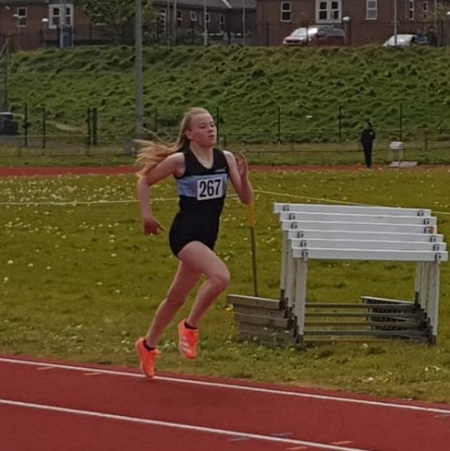
Under 13 Girl Sophie Webster who is coached by Steve Choules was another record breaker over 600 metres with a time of 1m46.10secs UK Ranked 4th so far in 2021. In better conditions and with stronger opposition in a carefully selected race programme we hope she will go much quicker as the season progresses.
Under 11 Girl Isla BATER set another Club Record over 600 metres with a time of 1m54.04secs – this was an mightily impressive performance and a solo ‘gun to tape’ victory.

While these were the stand out performances there were a host of other superb efforts throughout the day including a total of 26 PERSONAL BESTS
Under 11 Girls:
Isla Bater 150m/22.99secs PB; 600m/1m54.04secs PB Club Record
Genevieve Beer 600m/2m10.78secs
Under 13 Girls:
Sophie Webster 100m/14.53secs PB; 600m/1m46.10secs PB Club Record; Long Jump/4.01m PB
Eleanor Foster 150m/ 22.38secs PB; 600m/1m48.52secs PB; Long Jump/3.90m PB
Niamh Bourke 100m/15.18secs PB; 150m/22.75secs PB; 600m/2m00.14secs PB
Under 13 Boys:
Stanley Smith 100m/14.3secs PB; 150m/21.77secs PB; 600m/1m54.22secs PB
Adam Foster 150m/22.12secs PB; 600m/1m53.39secs PB; Long Jump 3.81m PB
Under 15 Girls:
Eden Robinson 100m/12.50secs PB Club Record; 200m/25.37secs PB Club Record; Long Jump 5.47m PB Club Record
Under 15 Boys:
Christopher Oliveira 300m/41.26secs PB; 800m/2m14.36secs
Sandy Garrick 100m/12.91secs PB 200m/26.97 PB; Long Jump/5.13m PB
Under 17 Women:
Izzy Beer HJ/1.40m; 80m Hurdles/12.72secs PB
Senior Men:
James McKibbin 3000m/9m29.92secs PB

