WINTER FIXTURES 2017-18


Sunday 8th October - Stover School
Sunday 12th November - Newquay
Sunday 3rd December - Exeter (includes Devon County Champs)
Sunday 14th January – Westward Ho !
Sunday 11th February – Plymouth
Sunday 4th March – Redruth

=================================================================================

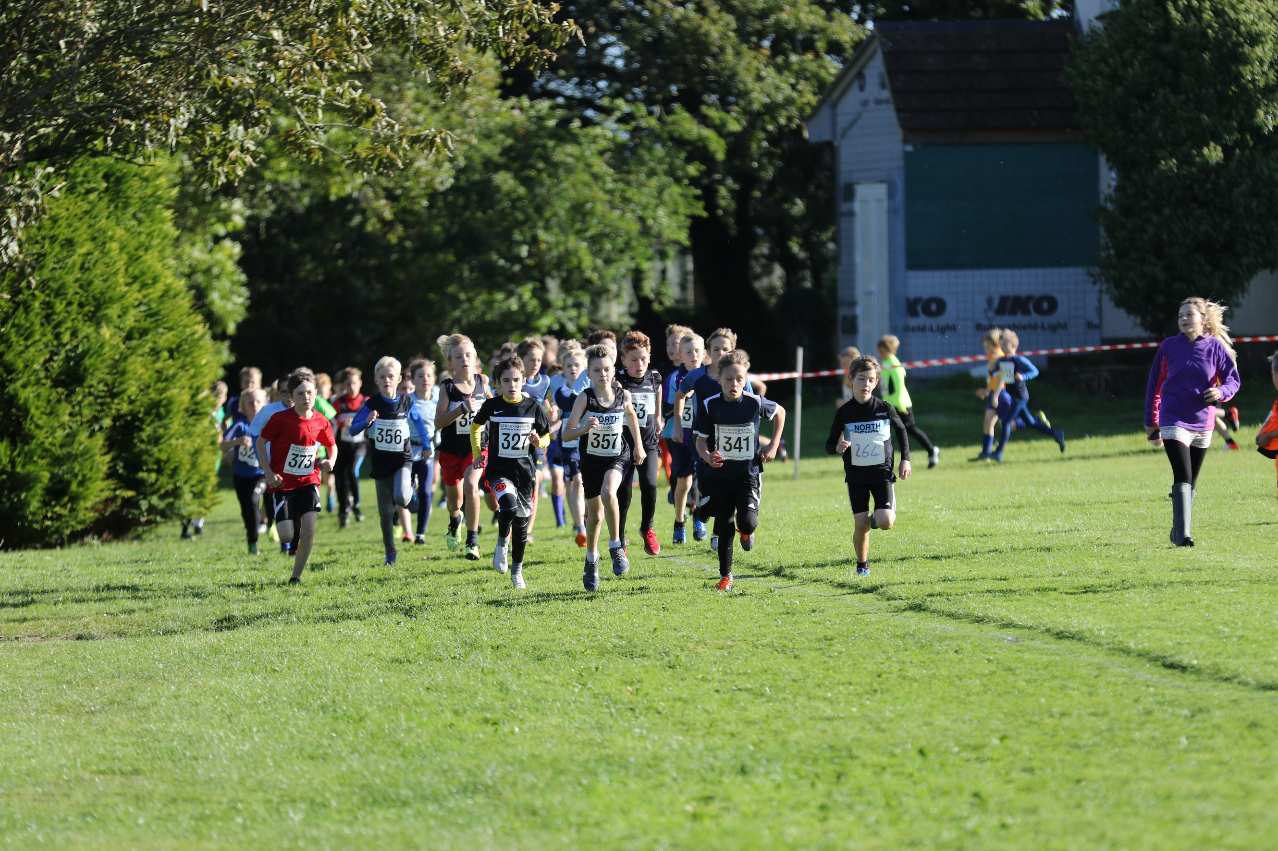
GLIDDON & SQUIRE NORTH DEVON LEAGUE
www.northdevonxcleague.weebly.com

Race 1: 10am Sunday 24th September at Bideford - Hosts Kingsley School
Race 2: 10am Sunday 15th October at Shebbear - Hosts Shebbear College
Race 3: 10am Sunday 5th November at Coxleigh Barton - Hosts NDAC/Family Gay
Race 4: 10am Sunday 26th November at West Buckland - Hosts West Buckland School
Race 5: 11am Sunday 14th January at Westward Ho! (combined with Westward League) Hosts Bideford AAC
Race 5: 10am Sunday 4th February at West Buckland - Finals and Presentations

==================================================================================

Regional and National fixtures
Saturday 7th January - South West Inter Counties Champs (venue to be decided)
Saturday 20th January - Devon County Schools at Stover School
Saturday 3rd February - SW Schools (Devon to host - probably at Stover))
Saturday 10th March - CAU Inter Counties
Saturday 17th March - English Schools AA Champs at Temple Newsom, Leeds

=====================================================================================

