logo reversed out with tpis.jpg

**CHARLES STANLEY**

**WESTWARD XC LEAGUE 2018-19**

**Information**

**Venue:**  **Stover School, Stover, Newton Abbot TQ12 6QG**

**Date:** **Sunday 10th February 2019**

**Timetable:**

**U11 (1630m) 12:15 1 Medium Lap**

**U13G (3070m) 12:30 2 Medium Laps**

**U13B (3070m) 12:50 2 Medium Laps**

**SW and U17M/W (5690m) 1:10 1 Medium & 2 Large Laps**

**U15G/B (4250m) 1:40 2 Large Laps**

**SM (8310m) 2:10 4 Large Laps**

***UK Athletics Permit Number 85:18***

**Directions:**

For those Runners and spectators approaching from the A38, please exit the Drumbridges junction following the signpost for Newton Abbott (A382).

The entrance to Stover School is approximately ½ mile on your left (past the entrance to Stover County Park!). Please refer to map below.

**IMPORTANT NOTE:** Whilst ample free parking is provided, it is politely requested that NO DOGS are brought on site as the races are held on school grounds. Dogs are however allowed at the nearby Stover Country Park

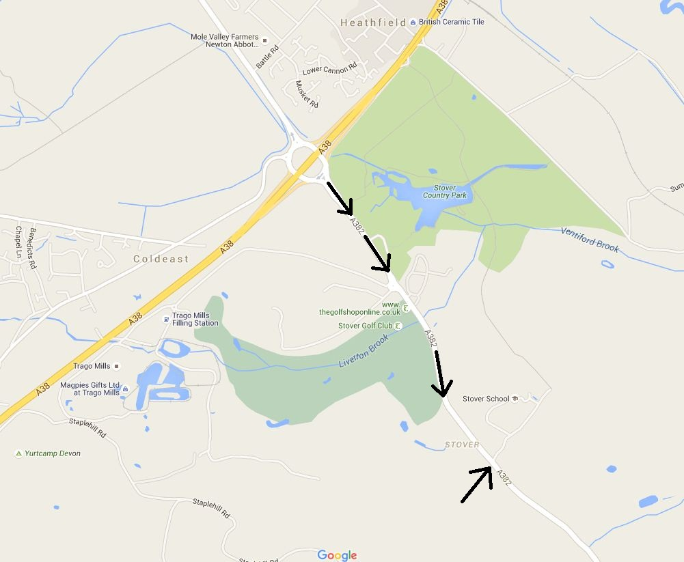

**Facilities:**

* A selection of hot and cold drinks and snacks available
* Separate Male/Female changing rooms are available
* Free on-site parking
* Medical cover provided by M.E.T Services (on site 11.45-15.00)

**Additional Information:**

Stover School

<http://www.stover.co.uk/>

Westward League

<http://www.city-runs.co.uk/westward/>

AA Route Finder

<http://www.theaa.com/route-planner/index.jsp>